**This Keyword:-**

it is special type of keyword, whenever the local and global variable names are same to differentiate between them we use **This Keyword.**

this keyword in Java is a special keyword that can be used to represent the current object or instance of any [class in Java](http://javarevisited.blogspot.com/2011/10/class-in-java-programming-general.html). “this” keyword can also call the constructor of the same class in Java and is used to call overloaded constructor

Example:

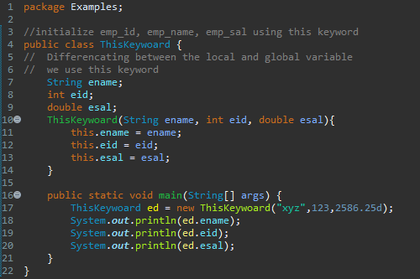

**Blocks**

Java provide 2 blocks called SIB (Static initialization block) and IIB (instance initialization block)

Static initialization block (SIB)

* Any block which is mentioned with the keyword static is called as SIB.
* It is executed before the main method.
* There can be n numbers of static blocks.
* The order of execution is sequence.

Syntax:

Static {

//statements

}

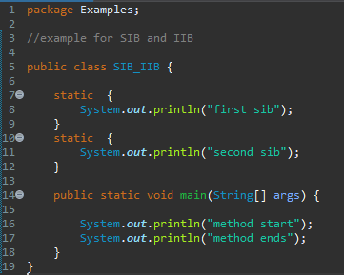

Instance initialization block (IIB)

* Any block which is not declared with the keyword static is called as IIB.
* Whenever an object is created IIb get invoked.
* There can be n number of IIb, the order of execution is sequence.

Syntax

{

//statement

}

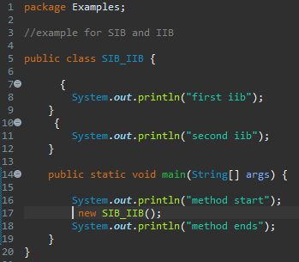

Predict the output of the below program

